CS610p Quiz 6 Solution

For paid solution DM us on whatsapp 03454919604

For more lms activities solution (Assignments ,GDBs ,Quizez ) Solutions Subscribe our youtube channel
https://youtube.com/@amb-e2v?si=Ocibrfl1Fg0n6Umt
https://youtube.com/@amb-e2v?si=Ocibrfl1Fg0n6Umt
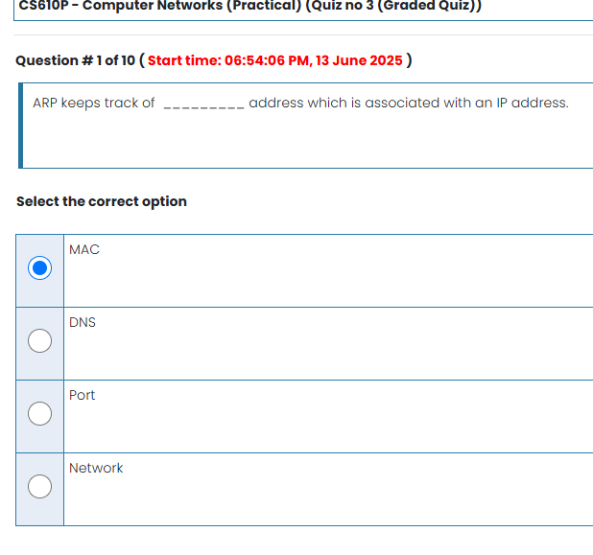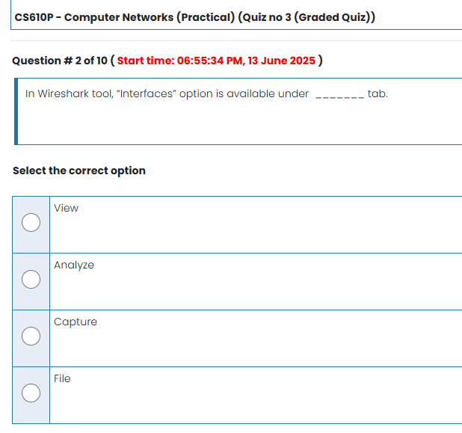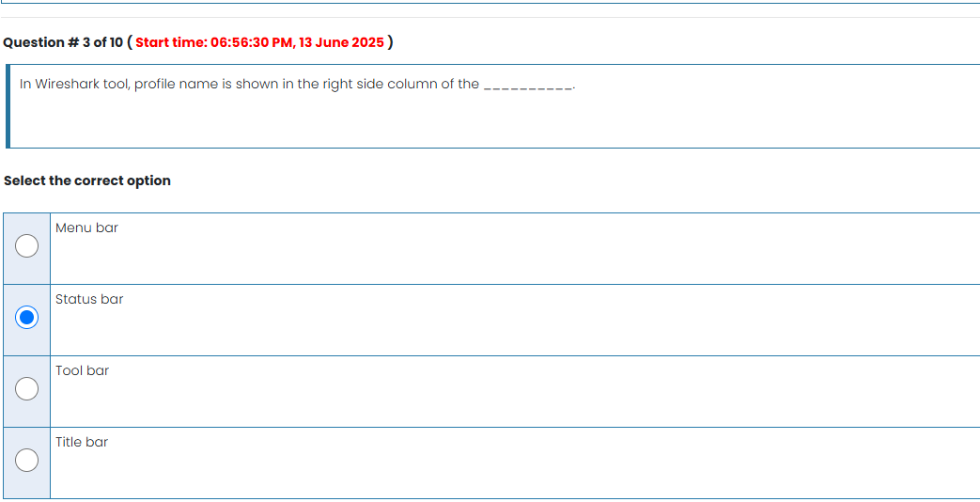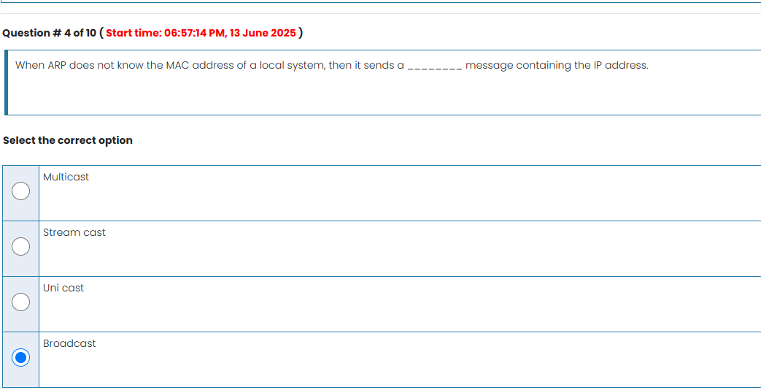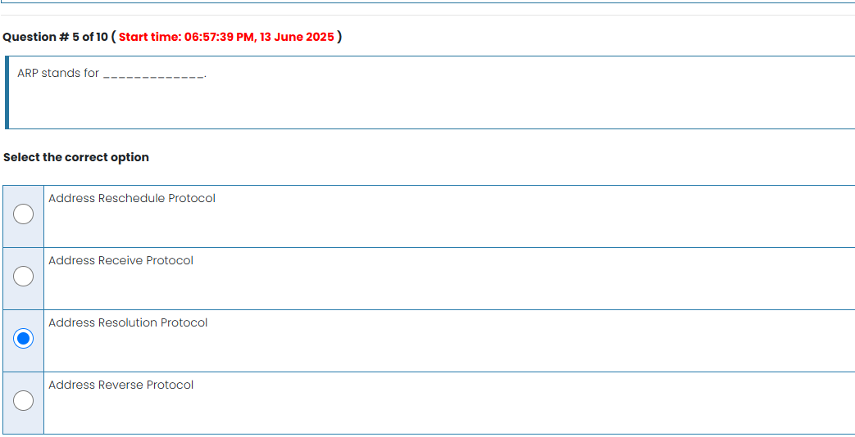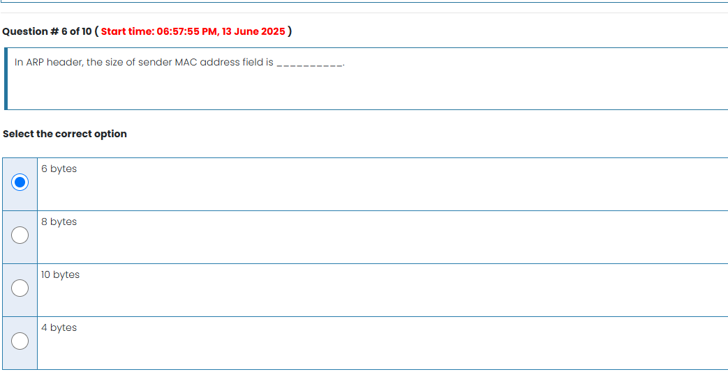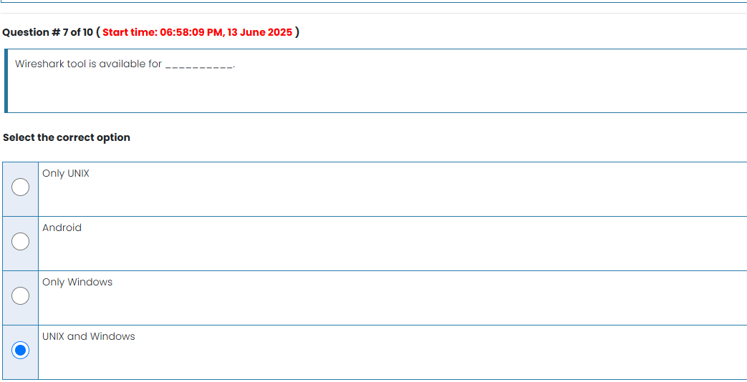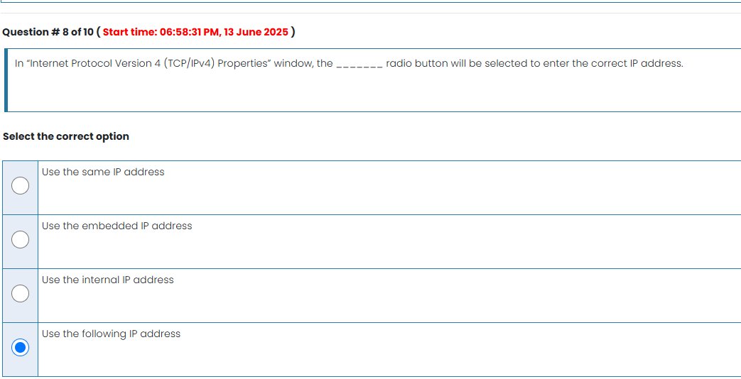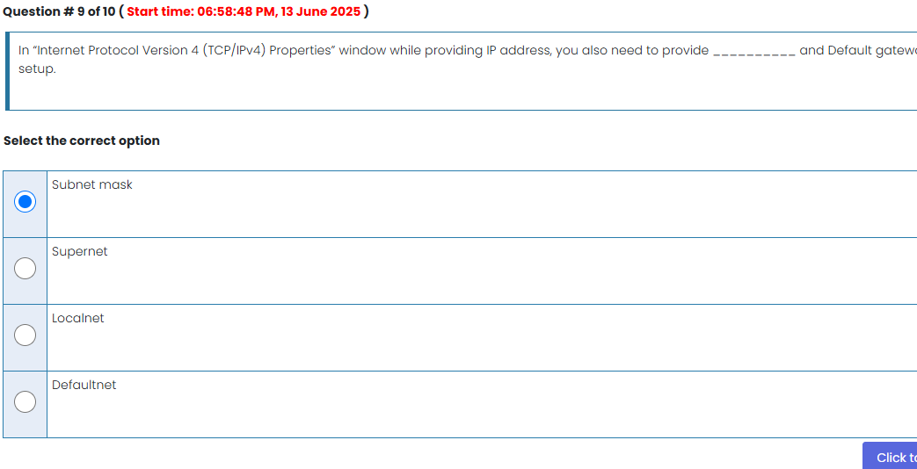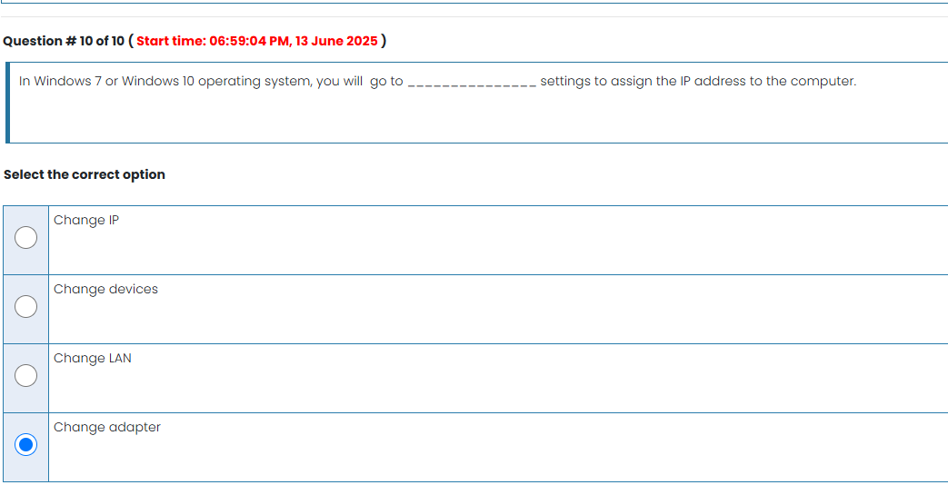
Visit for more quiz
https://youtube.com/@amb-e2v?si=Ocibrfl1Fg0n6Umt

